Ball Game project
Documentation Report

Filename: | Ball Game project.docx
Status: | Draft
Date: | 28.11.2025
Author: | David Hill

Table of contents
Ball Game project: Project Model 3
Ball Game structure - analysis: Class Diagram [UML] 4
Ball Game structure - design: Class Diagram [UML] 9
Ball Game behaviour - Design: Sequence Diagram 24
States of the Ball: State Machine Diagram 36
Ball Game requirements: Use Case Diagram 43

Ball Game project: Project Model
The Ball Game project is concerned with developing a video game, where the player attempts to break through a wall by knocking out bricks with a ball, which he or she bounces on his paddle.
Status of project model: draft
Project manager: David Hill
Personnel:
Person name | Email address | Contact information
David Hill | mailto:info@metacase.com | Park Court  Upper Essex Street  City 5  B8 6QB
Joe Smith | mailto:info@metacase.com | www.metacase.com

Project model picture: Ball Game project
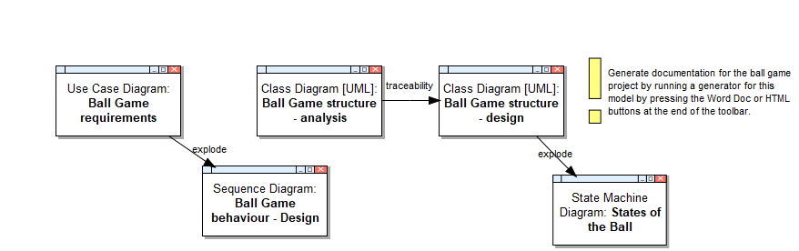
Documentation includes following graphs and subprojects:
Graph name | Documentation
Ball Game structure - analysis | Preliminary classes of the game are identified.
Ball Game structure - design | Ball game structure class diagram displays basic structure of the ball game. Game's idea is to remove all the bricks from the wall by striking them with the ball.
Ball Game behaviour - Design | This model describes interactions among the Ball game objects during the game.
States of the Ball | This diagram describes the states of the ball and possible transitions between the states. It reuses events and operations from the class diagram (e.g. Start game, move, calculateNewDirection).
Ball Game requirements | This model describes the use cases for the ball game application.

Generated from MetaEdit+ project documentation report

Ball Game structure - analysis: Class Diagram [UML]
Graph properties:
Model name | Ball Game structure - analysis
Status | draft
Authors | Joe Smith
Documentation | Preliminary classes of the game are identified.
Show Owned? | F

Diagram picture: Ball Game structure - analysis
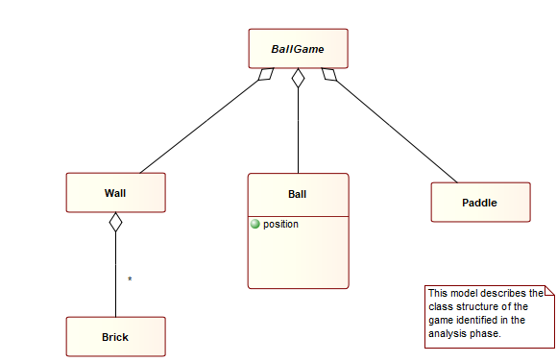

Graph dictionary
Object | Type of Object | Documentation
Ball | Class [UML]
BallGame | Class [UML]
Brick | Class [UML]
Paddle | Class [UML]
Wall | Class [UML]
This model describes the class structure of the game identified in the analys... | Note text

Ball: Class [UML]
Properties:
Class name | Ball
Attributes | +position
Operations
Package
Abstract? | F
Active? | F
Stereotype
Overridability
Role
Parameters
Constraints
Invariant
Derivation rules
Responsibility
Documentation
Simple symbol? | F

Ball relationships:
In role | In relationship | With objects(s) | In role
: Part | : Aggregation | BallGame | : Whole

Ball links:
Link type | Graph's name
Decomposition | none
Explosions | none

BallGame: Class [UML]
Properties:
Class name | BallGame
Attributes
Operations
Package
Abstract? | T
Active? | F
Stereotype
Overridability
Role
Parameters
Constraints
Invariant
Derivation rules
Responsibility
Documentation
Simple symbol? | T

BallGame relationships:
In role | In relationship | With objects(s) | In role
: Whole | : Aggregation | Wall | : Part
: Whole | : Aggregation | Ball | : Part
: Whole | : Aggregation | Paddle | : Part

BallGame links:
Link type | Graph's name
Decomposition | none
Explosions | none

Brick: Class [UML]
Properties:
Class name | Brick
Attributes
Operations
Package
Abstract? | F
Active? | F
Stereotype
Overridability
Role
Parameters
Constraints
Invariant
Derivation rules
Responsibility
Documentation
Simple symbol? | T

Brick relationships:
In role | In relationship | With objects(s) | In role
: Part | : Aggregation | Wall | : Whole

Brick links:
Link type | Graph's name
Decomposition | none
Explosions | none

Paddle: Class [UML]
Properties:
Class name | Paddle
Attributes
Operations
Package
Abstract? | F
Active? | F
Stereotype
Overridability
Role
Parameters
Constraints
Invariant
Derivation rules
Responsibility
Documentation
Simple symbol? | T

Paddle relationships:
In role | In relationship | With objects(s) | In role
: Part | : Aggregation | BallGame | : Whole

Paddle links:
Link type | Graph's name
Decomposition | none
Explosions | none

Wall: Class [UML]
Properties:
Class name | Wall
Attributes
Operations
Package
Abstract? | F
Active? | F
Stereotype
Overridability
Role
Parameters
Constraints
Invariant
Derivation rules
Responsibility
Documentation
Simple symbol? | T

Wall relationships:
In role | In relationship | With objects(s) | In role
: Part | : Aggregation | BallGame | : Whole
: Whole | : Aggregation | Brick | : Part

Wall links:
Link type | Graph's name
Decomposition | none
Explosions | none

This model describes the class structure of the game identified in the analys...: Note text
Properties:
Note text | This model describes the class structure of the game identified in the analysis phase.
Stereotype

This model describes the class structure of the game identified in the analys... relationships:
none

This model describes the class structure of the game identified in the analys... links:
Link type | Graph's name
Decomposition | none
Explosions | none

Sub-objects:

Joe Smith: Person
Properties:
Name | Joe Smith
E-mail | mailto:info@metacase.com
Contact address | www.metacase.com

+position: Attribute [UML]
Properties:
Name | position
Data type
Default value
Multiplicity
Ordered? | F
Unique? | T
Sequence? | F
Stereotype
Visibility | public
Scope | instance
Access
Derived? | F
Constraints
Documentation | The ball must include location informtion.

Ball Game structure - design: Class Diagram [UML]
Graph properties:
Model name | Ball Game structure - design
Status | draft
Authors | David Hill
Documentation | Ball game structure class diagram displays basic structure of the ball game. Game's idea is to remove all the bricks from the wall by striking them with the ball.
Show Owned? | F

Diagram picture: Ball Game structure - design
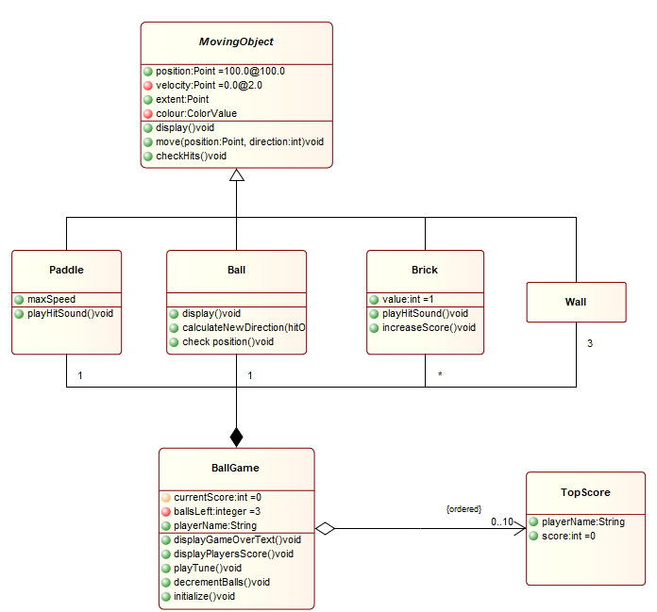

Graph dictionary
Object | Type of Object | Documentation
Ball | Class [UML] | Ball is the basic element of the game. Player tries to remove bricks by hitting them with the ball.
BallGame | Class [UML] | This is the main application class.
Brick | Class [UML] | Single element of the wall. These will disappear, when the ball hits them.
MovingObject | Class [UML] | MovingObject is an abstract class for all moving components of the ball game.
Paddle | Class [UML] | Player tries to keep the ball in play by hitting it with the paddle.
TopScore | Class [UML] | Stores one of the top scores and the player who achieved it.
Wall | Class [UML] | Walls are generally immobile; the ball bounces back off them giving no points.

Ball: Class [UML]
Properties:
Class name | Ball
Attributes
Operations | +display()void , +calculateNewDirection(hitObject:MovingObject)void , +check position()void
Package | Game
Abstract? | F
Active? | F
Stereotype
Overridability
Role
Parameters
Constraints
Invariant
Derivation rules
Responsibility
Documentation | Ball is the basic element of the game. Player tries to remove bricks by hitting them with the ball.
Simple symbol? | F

Ball relationships:
In role | In relationship | With objects(s) | In role
: Part | : Aggregation | Paddle | : Part
 |  | Brick | : Part
 |  | Wall | : Part
 |  | BallGame | : Whole
: Specialization | : Generalization [UML] | Wall | : Specialization
 |  | Paddle | : Specialization
 |  | Brick | : Specialization
 |  | MovingObject | : Superclass

Ball links:
Link type | Graph's name
Decomposition | none
Explosions | States of the Ball

BallGame: Class [UML]
Properties:
Class name | BallGame
Attributes | #currentScore:int =0 , -ballsLeft:integer =3 , +playerName:String
Operations | +displayGameOverText()void , +displayPlayersScore()void , +playTune()void , +decrementBalls()void , +initialize()void
Package | Game
Abstract? | F
Active? | F
Stereotype
Overridability
Role
Parameters
Constraints
Invariant
Derivation rules
Responsibility
Documentation | This is the main application class.
Simple symbol? | F

BallGame relationships:
In role | In relationship | With objects(s) | In role
: Whole | : Aggregation | TopScore | : Part
: Whole | : Aggregation | Paddle | : Part
 |  | Brick | : Part
 |  | Ball | : Part
 |  | Wall | : Part

BallGame links:
Link type | Graph's name
Decomposition | none
Explosions | none

Brick: Class [UML]
Properties:
Class name | Brick
Attributes | +value:int =1
Operations | +playHitSound()void , +increaseScore()void
Package | Game
Abstract? | F
Active? | F
Stereotype
Overridability
Role
Parameters
Constraints
Invariant
Derivation rules
Responsibility
Documentation | Single element of the wall. These will disappear, when the ball hits them.
Simple symbol? | F

Brick relationships:
In role | In relationship | With objects(s) | In role
: Part | : Aggregation | Paddle | : Part
 |  | Ball | : Part
 |  | Wall | : Part
 |  | BallGame | : Whole
: Specialization | : Generalization [UML] | Wall | : Specialization
 |  | Paddle | : Specialization
 |  | Ball | : Specialization
 |  | MovingObject | : Superclass

Brick links:
Link type | Graph's name
Decomposition | none
Explosions | none

MovingObject: Class [UML]
Properties:
Class name | MovingObject
Attributes | +position:Point =100.0@100.0 , -velocity:Point =0.0@2.0 , +extent:Point , -colour:ColorValue
Operations | +display()void , +move(position:Point, direction:int)void , +checkHits()void
Package | Game
Abstract? | T
Active? | F
Stereotype
Overridability
Role | model
Parameters
Constraints
Invariant
Derivation rules
Responsibility
Documentation | MovingObject is an abstract class for all moving components of the ball game.
Simple symbol? | F

MovingObject relationships:
In role | In relationship | With objects(s) | In role
: Superclass | : Generalization [UML] | Wall | : Specialization
 |  | Paddle | : Specialization
 |  | Brick | : Specialization
 |  | Ball | : Specialization

MovingObject links:
Link type | Graph's name
Decomposition | none
Explosions | none

Paddle: Class [UML]
Properties:
Class name | Paddle
Attributes | +maxSpeed
Operations | +playHitSound()void
Package | Game
Abstract? | F
Active? | F
Stereotype
Overridability
Role
Parameters
Constraints
Invariant
Derivation rules
Responsibility
Documentation | Player tries to keep the ball in play by hitting  it with the paddle.
Simple symbol? | F

Paddle relationships:
In role | In relationship | With objects(s) | In role
: Part | : Aggregation | Brick | : Part
 |  | Ball | : Part
 |  | Wall | : Part
 |  | BallGame | : Whole
: Specialization | : Generalization [UML] | Wall | : Specialization
 |  | Brick | : Specialization
 |  | Ball | : Specialization
 |  | MovingObject | : Superclass

Paddle links:
Link type | Graph's name
Decomposition | none
Explosions | none

TopScore: Class [UML]
Properties:
Class name | TopScore
Attributes | +playerName:String , +score:int =0
Operations
Package | Game
Abstract? | F
Active? | F
Stereotype
Overridability
Role
Parameters
Constraints
Invariant
Derivation rules
Responsibility
Documentation | Stores one of the top scores and the player who achieved it.
Simple symbol? | F

TopScore relationships:
In role | In relationship | With objects(s) | In role
: Part | : Aggregation | BallGame | : Whole

TopScore links:
Link type | Graph's name
Decomposition | none
Explosions | none

Wall: Class [UML]
Properties:
Class name | Wall
Attributes
Operations
Package
Abstract? | F
Active? | F
Stereotype
Overridability
Role
Parameters
Constraints
Invariant
Derivation rules
Responsibility
Documentation | Walls are generally immobile; the ball bounces back off them giving no points.
Simple symbol? | T

Wall relationships:
In role | In relationship | With objects(s) | In role
: Part | : Aggregation | Paddle | : Part
 |  | Brick | : Part
 |  | Ball | : Part
 |  | BallGame | : Whole
: Specialization | : Generalization [UML] | Paddle | : Specialization
 |  | Brick | : Specialization
 |  | Ball | : Specialization
 |  | MovingObject | : Superclass

Wall links:
Link type | Graph's name
Decomposition | none
Explosions | none

Sub-objects:

David Hill: Person
Properties:
Name | David Hill
E-mail | mailto:info@metacase.com
Contact address | Park Court  Upper Essex Street  City 5  B8 6QB

+display()void: Operation [UML]
Properties:
Operation name | display
Parameters
Return type
Overridability
Stereotype
Visibility | public
Operation type | instance
Query? | F
Preconditions
Postconditions
Body
Documentation | Overriden from superclass to display a round ball rather than a square

+calculateNewDirection(hitObject:MovingObject)void: Operation [UML]
Properties:
Operation name | calculateNewDirection
Parameters | in hitObject:MovingObject
Return type
Overridability
Stereotype
Visibility | public
Operation type | instance
Query? | F
Preconditions
Postconditions
Body
Documentation

in hitObject:MovingObject: Parameter
Properties:
Parameter | hitObject
Data type | MovingObject
Direction | in
Default value
Effect
Exception? | F
Stream? | F

+check position()void: Operation [UML]
Properties:
Operation name | check position
Parameters
Return type
Overridability
Stereotype
Visibility | public
Operation type | instance
Query? | F
Preconditions
Postconditions
Body
Documentation | Returns the location of the ball.

Game: Package
Properties:
Package name | Game
Stereotype | modelLibrary
Documentation | Ball game packace include all the components of the ball game application. Because the application is small not other packages are used for categorization.

#currentScore:int =0: Attribute [UML]
Properties:
Name | currentScore
Data type | int
Default value | 0
Multiplicity
Ordered? | F
Unique? | T
Sequence? | F
Stereotype
Visibility | protected
Scope | instance
Access
Derived? | F
Constraints
Documentation | Stores the player's score in the current game.

-ballsLeft:integer =3: Attribute [UML]
Properties:
Name | ballsLeft
Data type | integer
Default value | 3
Multiplicity
Ordered? | F
Unique? | T
Sequence? | F
Stereotype
Visibility | private
Scope | instance
Access
Derived? | F
Constraints
Documentation | How many balls player has left.

+playerName:String: Attribute [UML]
Properties:
Name | playerName
Data type | String
Default value
Multiplicity
Ordered? | F
Unique? | T
Sequence? | F
Stereotype
Visibility | public
Scope | instance
Access
Derived? | F
Constraints
Documentation | Name of the player.

+displayGameOverText()void: Operation [UML]
Properties:
Operation name | displayGameOverText
Parameters
Return type
Overridability
Stereotype
Visibility | public
Operation type | instance
Query? | F
Preconditions
Postconditions
Body
Documentation | This displays the Game Over text, when game ends. Game can end either when all bricks have disappeared or when player has missed all of his/hers balls.

+displayPlayersScore()void: Operation [UML]
Properties:
Operation name | displayPlayersScore
Parameters
Return type
Overridability
Stereotype
Visibility | public
Operation type | instance
Query? | F
Preconditions
Postconditions
Body
Documentation | This displays player's current score after the Game over text.

+playTune()void: Operation [UML]
Properties:
Operation name | playTune
Parameters
Return type
Overridability
Stereotype
Visibility | public
Operation type | instance
Query? | F
Preconditions
Postconditions
Body
Documentation | Plays a tune, when player misses the ball.

+decrementBalls()void: Operation [UML]
Properties:
Operation name | decrementBalls
Parameters
Return type
Overridability
Stereotype
Visibility | public
Operation type | instance
Query? | F
Preconditions
Postconditions
Body
Documentation | When player misses the ball, decrement balls left

+initialize()void: Operation [UML]
Properties:
Operation name | initialize
Parameters
Return type
Overridability
Stereotype
Visibility | public
Operation type | instance
Query? | F
Preconditions
Postconditions
Body
Documentation | When the game is started

+value:int =1: Attribute [UML]
Properties:
Name | value
Data type | int
Default value | 1
Multiplicity
Ordered? | F
Unique? | T
Sequence? | F
Stereotype
Visibility | public
Scope | instance
Access
Derived? | F
Constraints
Documentation | Value of the brick. When ball hits the brick, value will be added to player's currentScore.

+playHitSound()void: Operation [UML]
Properties:
Operation name | playHitSound
Parameters
Return type
Overridability
Stereotype
Visibility | public
Operation type | instance
Query? | F
Preconditions
Postconditions
Body
Documentation | When the ball hits a brick or a paddle, it makes a sound.

+increaseScore()void: Operation [UML]
Properties:
Operation name | increaseScore
Parameters
Return type
Overridability
Stereotype
Visibility | public
Operation type | instance
Query? | F
Preconditions
Postconditions
Body
Documentation | When then ball hits a brick it will disappear and the value of the brick will be added to player's currentScores.

+position:Point =100.0@100.0: Attribute [UML]
Properties:
Name | position
Data type | Point
Default value | 100.0@100.0
Multiplicity
Ordered? | F
Unique? | T
Sequence? | F
Stereotype
Visibility | public
Scope | class
Access
Derived? | F
Constraints
Documentation | Position stores the current location of the top left corner of the moving object in the game.

-velocity:Point =0.0@2.0: Attribute [UML]
Properties:
Name | velocity
Data type | Point
Default value | 0.0@2.0
Multiplicity
Ordered? | F
Unique? | T
Sequence? | F
Stereotype
Visibility | private
Scope | instance
Access
Derived? | F
Constraints
Documentation | Stores the direction and speed of the movement. Positive x values are to the right, positive y values up

+extent:Point: Attribute [UML]
Properties:
Name | extent
Data type | Point
Default value
Multiplicity
Ordered? | F
Unique? | T
Sequence? | F
Stereotype
Visibility | public
Scope | instance
Access
Derived? | F
Constraints
Documentation | Moving objects have width and height

-colour:ColorValue: Attribute [UML]
Properties:
Name | colour
Data type | ColorValue
Default value
Multiplicity
Ordered? | F
Unique? | T
Sequence? | F
Stereotype
Visibility | private
Scope | instance
Access
Derived? | F
Constraints
Documentation | Colour of the moving object.

+display()void: Operation [UML]
Properties:
Operation name | display
Parameters
Return type
Overridability
Stereotype
Visibility | public
Operation type | instance
Query? | F
Preconditions
Postconditions
Body
Documentation | Displays the object at its current position. The default is to fill its extent with its colour; subclasses can override for more interesting shapes and effects.

+move(position:Point, direction:int)void: Operation [UML]
Properties:
Operation name | move
Parameters | in position:Point , in direction:int
Return type
Overridability
Stereotype | action
Visibility | public
Operation type | instance
Query? | F
Preconditions | Is not outside the game field, ie. player has not missed the ball.
Postconditions
Body
Documentation | Move changes the location and direction of the moving object in the game field according to the given position and direction.

in position:Point: Parameter
Properties:
Parameter | position
Data type | Point
Direction | in
Default value
Effect
Exception? | F
Stream? | F

in direction:int: Parameter
Properties:
Parameter | direction
Data type | int
Direction | in
Default value
Effect
Exception? | F
Stream? | F

+checkHits()void: Operation [UML]
Properties:
Operation name | checkHits
Parameters
Return type
Overridability
Stereotype
Visibility | public
Operation type | instance
Query? | F
Preconditions
Postconditions
Body
Documentation | Check whether moving object has hit some other object.

+maxSpeed: Attribute [UML]
Properties:
Name | maxSpeed
Data type
Default value
Multiplicity
Ordered? | F
Unique? | T
Sequence? | F
Stereotype
Visibility | public
Scope | instance
Access
Derived? | F
Constraints
Documentation | Maximum speed of the paddle can change during the game

+score:int =0: Attribute [UML]
Properties:
Name | score
Data type | int
Default value | 0
Multiplicity
Ordered? | F
Unique? | T
Sequence? | F
Stereotype
Visibility | public
Scope | instance
Access
Derived? | F
Constraints
Documentation

Ball Game behaviour - Design: Sequence Diagram
Graph properties:
Model name | Ball Game behaviour - Design
Status | draft
Authors | David Hill
Documentation | This model describes interactions among the Ball game objects during the game.

Diagram picture: Ball Game behaviour - Design
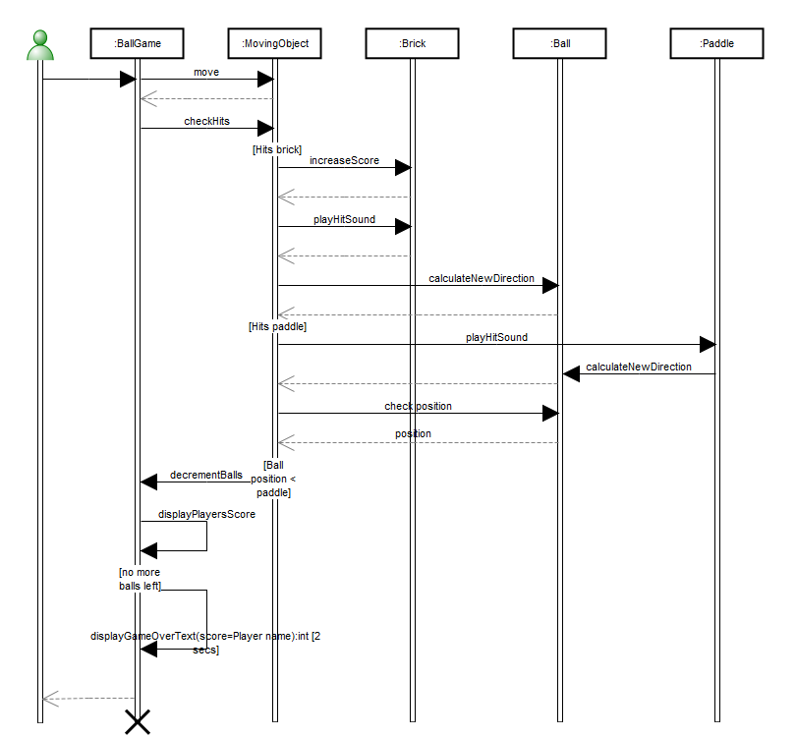

Graph dictionary
Object | Type of Object | Documentation
:Ball | Lifeline object
:BallGame | Lifeline object
:Brick | Lifeline object
:MovingObject | Lifeline object
:Paddle | Lifeline object
Outside actor | Outside actor

:Ball: Lifeline object
Properties:
Object name
Class | Ball
Stop? | F
Documentation

:Ball relationships:
In role | In relationship | With objects(s) | In role
: Message to | calculateNewDirection: Call | :MovingObject | : Message from
: Message to | calculateNewDirection: Call | :Paddle | : Message from
: Message to | check position: Call | :MovingObject | : Message from
: Return from | : Return | :MovingObject | : Return to
: Return from | position: Return | :MovingObject | : Return to
: Return from | : Return | :MovingObject | : Return to

:Ball links:
Link type | Graph's name
Decomposition | none
Explosions | none

:BallGame: Lifeline object
Properties:
Object name
Class | BallGame
Stop? | T
Documentation

:BallGame relationships:
In role | In relationship | With objects(s) | In role
: Message from | displayPlayersScore: Call | :BallGame | : Message to
: Message from | displayGameOverText: Call | :BallGame | : Message to
: Message from | move: Call | :MovingObject | : Message to
: Message from | checkHits: Call | :MovingObject | : Message to
: Message to | displayPlayersScore: Call | :BallGame | : Message from
: Message to | displayGameOverText: Call | :BallGame | : Message from
: Message to | decrementBalls: Call | :MovingObject | : Message from
: Message to | : Call | Outside actor | : Message from
: Return from | : Return | Outside actor | : Return to
: Return to | : Return | :MovingObject | : Return from

:BallGame links:
Link type | Graph's name
Decomposition | none
Explosions | none

:Brick: Lifeline object
Properties:
Object name
Class | Brick
Stop? | F
Documentation

:Brick relationships:
In role | In relationship | With objects(s) | In role
: Message to | increaseScore: Call | :MovingObject | : Message from
: Message to | playHitSound: Call | :MovingObject | : Message from
: Return from | : Return | :MovingObject | : Return to
: Return from | : Return | :MovingObject | : Return to

:Brick links:
Link type | Graph's name
Decomposition | none
Explosions | none

:MovingObject: Lifeline object
Properties:
Object name
Class | MovingObject
Stop? | F
Documentation

:MovingObject relationships:
In role | In relationship | With objects(s) | In role
: Message from | check position: Call | :Ball | : Message to
: Message from | decrementBalls: Call | :BallGame | : Message to
: Message from | playHitSound: Call | :Brick | : Message to
: Message from | playHitSound: Call | :Paddle | : Message to
: Message from | increaseScore: Call | :Brick | : Message to
: Message from | calculateNewDirection: Call | :Ball | : Message to
: Message to | move: Call | :BallGame | : Message from
: Message to | checkHits: Call | :BallGame | : Message from
: Return from | : Return | :BallGame | : Return to
: Return to | : Return | :Brick | : Return from
: Return to | : Return | :Ball | : Return from
: Return to | position: Return | :Ball | : Return from
: Return to | : Return | :Ball | : Return from
: Return to | : Return | :Brick | : Return from

:MovingObject links:
Link type | Graph's name
Decomposition | none
Explosions | none

:Paddle: Lifeline object
Properties:
Object name
Class | Paddle
Stop? | F
Documentation

:Paddle relationships:
In role | In relationship | With objects(s) | In role
: Message from | calculateNewDirection: Call | :Ball | : Message to
: Message to | playHitSound: Call | :MovingObject | : Message from

:Paddle links:
Link type | Graph's name
Decomposition | none
Explosions | none

Outside actor: Outside actor
Properties:
none

Outside actor relationships:
In role | In relationship | With objects(s) | In role
: Message from | : Call | :BallGame | : Message to
: Return to | : Return | :BallGame | : Return from

Outside actor links:
Link type | Graph's name
Decomposition | none
Explosions | none

Sub-objects:

David Hill: Person
Properties:
Name | David Hill
E-mail | mailto:info@metacase.com
Contact address | Park Court  Upper Essex Street  City 5  B8 6QB

Ball: Class [UML]
Properties:
Class name | Ball
Attributes
Operations | +display()void , +calculateNewDirection(hitObject:MovingObject)void , +check position()void
Package | Game
Abstract? | F
Active? | F
Stereotype
Overridability
Role
Parameters
Constraints
Invariant
Derivation rules
Responsibility
Documentation | Ball is the basic element of the game. Player tries to remove bricks by hitting them with the ball.
Simple symbol? | F

+display()void: Operation [UML]
Properties:
Operation name | display
Parameters
Return type
Overridability
Stereotype
Visibility | public
Operation type | instance
Query? | F
Preconditions
Postconditions
Body
Documentation | Overriden from superclass to display a round ball rather than a square

+calculateNewDirection(hitObject:MovingObject)void: Operation [UML]
Properties:
Operation name | calculateNewDirection
Parameters | in hitObject:MovingObject
Return type
Overridability
Stereotype
Visibility | public
Operation type | instance
Query? | F
Preconditions
Postconditions
Body
Documentation

in hitObject:MovingObject: Parameter
Properties:
Parameter | hitObject
Data type | MovingObject
Direction | in
Default value
Effect
Exception? | F
Stream? | F

+check position()void: Operation [UML]
Properties:
Operation name | check position
Parameters
Return type
Overridability
Stereotype
Visibility | public
Operation type | instance
Query? | F
Preconditions
Postconditions
Body
Documentation | Returns the location of the ball.

Game: Package
Properties:
Package name | Game
Stereotype | modelLibrary
Documentation | Ball game packace include all the components of the ball game application. Because the application is small not other packages are used for categorization.

BallGame: Class [UML]
Properties:
Class name | BallGame
Attributes
Operations
Package
Abstract? | T
Active? | F
Stereotype
Overridability
Role
Parameters
Constraints
Invariant
Derivation rules
Responsibility
Documentation
Simple symbol? | T

Brick: Class [UML]
Properties:
Class name | Brick
Attributes | +value:int =1
Operations | +playHitSound()void , +increaseScore()void
Package | Game
Abstract? | F
Active? | F
Stereotype
Overridability
Role
Parameters
Constraints
Invariant
Derivation rules
Responsibility
Documentation | Single element of the wall. These will disappear, when the ball hits them.
Simple symbol? | F

+value:int =1: Attribute [UML]
Properties:
Name | value
Data type | int
Default value | 1
Multiplicity
Ordered? | F
Unique? | T
Sequence? | F
Stereotype
Visibility | public
Scope | instance
Access
Derived? | F
Constraints
Documentation | Value of the brick. When ball hits the brick, value will be added to player's currentScore.

+playHitSound()void: Operation [UML]
Properties:
Operation name | playHitSound
Parameters
Return type
Overridability
Stereotype
Visibility | public
Operation type | instance
Query? | F
Preconditions
Postconditions
Body
Documentation | When the ball hits a brick or a paddle, it makes a sound.

+increaseScore()void: Operation [UML]
Properties:
Operation name | increaseScore
Parameters
Return type
Overridability
Stereotype
Visibility | public
Operation type | instance
Query? | F
Preconditions
Postconditions
Body
Documentation | When then ball hits a brick it will disappear and the value of the brick will be added to player's currentScores.

MovingObject: Class [UML]
Properties:
Class name | MovingObject
Attributes | +position:Point =100.0@100.0 , -velocity:Point =0.0@2.0 , +extent:Point , -colour:ColorValue
Operations | +display()void , +move(position:Point, direction:int)void , +checkHits()void
Package | Game
Abstract? | T
Active? | F
Stereotype
Overridability
Role | model
Parameters
Constraints
Invariant
Derivation rules
Responsibility
Documentation | MovingObject is an abstract class for all moving components of the ball game.
Simple symbol? | F

+position:Point =100.0@100.0: Attribute [UML]
Properties:
Name | position
Data type | Point
Default value | 100.0@100.0
Multiplicity
Ordered? | F
Unique? | T
Sequence? | F
Stereotype
Visibility | public
Scope | class
Access
Derived? | F
Constraints
Documentation | Position stores the current location of the top left corner of the moving object in the game.

-velocity:Point =0.0@2.0: Attribute [UML]
Properties:
Name | velocity
Data type | Point
Default value | 0.0@2.0
Multiplicity
Ordered? | F
Unique? | T
Sequence? | F
Stereotype
Visibility | private
Scope | instance
Access
Derived? | F
Constraints
Documentation | Stores the direction and speed of the movement. Positive x values are to the right, positive y values up

+extent:Point: Attribute [UML]
Properties:
Name | extent
Data type | Point
Default value
Multiplicity
Ordered? | F
Unique? | T
Sequence? | F
Stereotype
Visibility | public
Scope | instance
Access
Derived? | F
Constraints
Documentation | Moving objects have width and height

-colour:ColorValue: Attribute [UML]
Properties:
Name | colour
Data type | ColorValue
Default value
Multiplicity
Ordered? | F
Unique? | T
Sequence? | F
Stereotype
Visibility | private
Scope | instance
Access
Derived? | F
Constraints
Documentation | Colour of the moving object.

+display()void: Operation [UML]
Properties:
Operation name | display
Parameters
Return type
Overridability
Stereotype
Visibility | public
Operation type | instance
Query? | F
Preconditions
Postconditions
Body
Documentation | Displays the object at its current position. The default is to fill its extent with its colour; subclasses can override for more interesting shapes and effects.

+move(position:Point, direction:int)void: Operation [UML]
Properties:
Operation name | move
Parameters | in position:Point , in direction:int
Return type
Overridability
Stereotype | action
Visibility | public
Operation type | instance
Query? | F
Preconditions | Is not outside the game field, ie. player has not missed the ball.
Postconditions
Body
Documentation | Move changes the location and direction of the moving object in the game field according to the given position and direction.

in position:Point: Parameter
Properties:
Parameter | position
Data type | Point
Direction | in
Default value
Effect
Exception? | F
Stream? | F

in direction:int: Parameter
Properties:
Parameter | direction
Data type | int
Direction | in
Default value
Effect
Exception? | F
Stream? | F

+checkHits()void: Operation [UML]
Properties:
Operation name | checkHits
Parameters
Return type
Overridability
Stereotype
Visibility | public
Operation type | instance
Query? | F
Preconditions
Postconditions
Body
Documentation | Check whether moving object has hit some other object.

Paddle: Class [UML]
Properties:
Class name | Paddle
Attributes | +maxSpeed
Operations | +playHitSound()void
Package | Game
Abstract? | F
Active? | F
Stereotype
Overridability
Role
Parameters
Constraints
Invariant
Derivation rules
Responsibility
Documentation | Player tries to keep the ball in play by hitting  it with the paddle.
Simple symbol? | F

+maxSpeed: Attribute [UML]
Properties:
Name | maxSpeed
Data type
Default value
Multiplicity
Ordered? | F
Unique? | T
Sequence? | F
Stereotype
Visibility | public
Scope | instance
Access
Derived? | F
Constraints
Documentation | Maximum speed of the paddle can change during the game

States of the Ball: State Machine Diagram
Graph properties:
Model name | States of the Ball
Status | frozen
Authors | Joe Smith
Documentation | This diagram describes the states of the ball and possible transitions between the states. It reuses events and operations from the class diagram (e.g. Start game, move, calculateNewDirection).

Diagram picture: States of the Ball
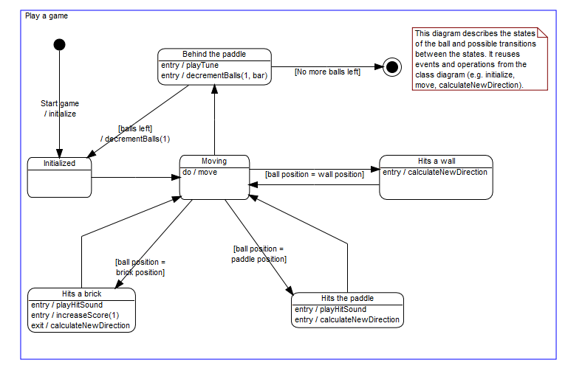

Graph dictionary
Object | Type of Object | Documentation
This diagram describes the states of the ball and possible transitions betwee... | Note text
Start | Start
Behind the paddle | State [UML] | When player misses the ball, the number of balls left decreases by one and a tune is played.
Hits a brick | State [UML] | When the ball hits a brick the Hit sound is played, the brick's value is added to the player's scores and new direction for the ball is calculated.
Hits a wall | State [UML] | When the ball hits the wall, a new direction for the ball is calculated.
Hits the paddle | State [UML] | When ball hits the paddle the Hit sound is played, and new direction for the ball is calculated.
Initialized | State [UML] | In the beginning the direction of the ball is initialized to 0 which means movement directly up.
Moving | State [UML] | When the game has begun, the ball is mostly moving with the current direction and speed.
Play a game | State [UML]
Stop | Stop

This diagram describes the states of the ball and possible transitions betwee...: Note text
Properties:
Note text | This diagram describes the states of the ball and possible transitions between the states. It reuses events and operations from the class diagram (e.g. initialize, move, calculateNewDirection).
Stereotype

This diagram describes the states of the ball and possible transitions betwee... relationships:
none

This diagram describes the states of the ball and possible transitions betwee... links:
Link type | Graph's name
Decomposition | none
Explosions | none

Start: Start
Properties:
none

Start relationships:
In role | In relationship | With objects(s) | In role
: From | initialize: Transition [UML] | Initialized | : To

Start links:
Link type | Graph's name
Decomposition | none
Explosions | none

Behind the paddle: State [UML]
Properties:
State name | Behind the paddle
Internal actions | entry / playTune , entry / decrementBalls(1, bar)
Documentation | When player misses the ball, the number of balls left decreases by one and a tune is played.
Symbol transparent? | F

Behind the paddle relationships:
In role | In relationship | With objects(s) | In role
: From | decrementBalls: Transition [UML] | Initialized | : To
: From | : Transition [UML] | Stop | : To
: To | : Transition [UML] | Moving | : From

Behind the paddle links:
Link type | Graph's name
Decomposition | none
Explosions | none

Hits a brick: State [UML]
Properties:
State name | Hits a brick
Internal actions | entry / playHitSound , entry / increaseScore(1) , exit / calculateNewDirection
Documentation | When the ball hits a brick the Hit sound is played, the brick's value is added to the player's scores and new direction for the ball is calculated.
Symbol transparent? | F

Hits a brick relationships:
In role | In relationship | With objects(s) | In role
: From | : Transition [UML] | Moving | : To
: To | : Transition [UML] | Moving | : From

Hits a brick links:
Link type | Graph's name
Decomposition | none
Explosions | none

Hits a wall: State [UML]
Properties:
State name | Hits a wall
Internal actions | entry / calculateNewDirection
Documentation | When the ball hits the wall, a new direction for the ball is calculated.
Symbol transparent? | F

Hits a wall relationships:
In role | In relationship | With objects(s) | In role
: From | : Transition [UML] | Moving | : To
: To | : Transition [UML] | Moving | : From

Hits a wall links:
Link type | Graph's name
Decomposition | none
Explosions | none

Hits the paddle: State [UML]
Properties:
State name | Hits the paddle
Internal actions | entry / playHitSound , entry / calculateNewDirection
Documentation | When ball hits the paddle the Hit sound is played, and new direction for the ball is calculated.
Symbol transparent? | F

Hits the paddle relationships:
In role | In relationship | With objects(s) | In role
: From | : Transition [UML] | Moving | : To
: To | : Transition [UML] | Moving | : From

Hits the paddle links:
Link type | Graph's name
Decomposition | none
Explosions | none

Initialized: State [UML]
Properties:
State name | Initialized
Internal actions
Documentation | In the beginning the direction of the ball is initialized to 0 which means movement directly up.
Symbol transparent? | F

Initialized relationships:
In role | In relationship | With objects(s) | In role
: From | : Transition [UML] | Moving | : To
: To | initialize: Transition [UML] | Start | : From
: To | decrementBalls: Transition [UML] | Behind the paddle | : From

Initialized links:
Link type | Graph's name
Decomposition | none
Explosions | none

Moving: State [UML]
Properties:
State name | Moving
Internal actions | do / move
Documentation | When the game has begun, the ball is mostly moving with the current direction and speed.
Symbol transparent? | F

Moving relationships:
In role | In relationship | With objects(s) | In role
: From | : Transition [UML] | Hits a wall | : To
: From | : Transition [UML] | Behind the paddle | : To
: From | : Transition [UML] | Hits the paddle | : To
: From | : Transition [UML] | Hits a brick | : To
: To | : Transition [UML] | Hits the paddle | : From
: To | : Transition [UML] | Hits a wall | : From
: To | : Transition [UML] | Initialized | : From
: To | : Transition [UML] | Hits a brick | : From

Moving links:
Link type | Graph's name
Decomposition | none
Explosions | none

Play a game: State [UML]
Properties:
State name | Play a game
Internal actions
Documentation
Symbol transparent? | T

Play a game relationships:
none

Play a game links:
Link type | Graph's name
Decomposition | none
Explosions | none

Stop: Stop
Properties:
none

Stop relationships:
In role | In relationship | With objects(s) | In role
: To | : Transition [UML] | Behind the paddle | : From

Stop links:
Link type | Graph's name
Decomposition | none
Explosions | none

Sub-objects:

Joe Smith: Person
Properties:
Name | Joe Smith
E-mail | mailto:info@metacase.com
Contact address | www.metacase.com

entry / playTune: Internal activity
Properties:
Activity | playTune
Activity label | entry
Arguments
Documentation

entry / decrementBalls(1, bar): Internal activity
Properties:
Activity | decrementBalls
Activity label | entry
Arguments | param1=1 , param2=bar
Documentation

param1=1: Argument
Properties:
Argument | 1
Parameter | in param1:dataType =2

in param1:dataType =2: Parameter
Properties:
Parameter | param1
Data type | dataType
Direction | in
Default value | 2
Effect
Exception? | F
Stream? | F

param2=bar: Argument
Properties:
Argument | bar
Parameter | out param2:dataType =defaultValue

out param2:dataType =defaultValue: Parameter
Properties:
Parameter | param2
Data type | dataType
Direction | out
Default value | defaultValue
Effect
Exception? | F
Stream? | F

entry / playHitSound: Internal activity
Properties:
Activity | playHitSound
Activity label | entry
Arguments
Documentation

entry / increaseScore(1): Internal activity
Properties:
Activity | increaseScore
Activity label | entry
Arguments | 1
Documentation

1: Argument
Properties:
Argument | 1
Parameter

exit / calculateNewDirection: Internal activity
Properties:
Activity | calculateNewDirection
Activity label | exit
Arguments
Documentation

entry / calculateNewDirection: Internal activity
Properties:
Activity | calculateNewDirection
Activity label | entry
Arguments
Documentation

entry / playHitSound: Internal activity
Properties:
Activity | playHitSound
Activity label | entry
Arguments
Documentation

entry / calculateNewDirection: Internal activity
Properties:
Activity | calculateNewDirection
Activity label | entry
Arguments
Documentation

do / move: Internal activity
Properties:
Activity | move
Activity label | do
Arguments
Documentation

Ball Game requirements: Use Case Diagram
Graph properties:
Model name | Ball Game requirements
Status | draft
Authors | Joe Smith
Documentation | This model describes the use cases for the ball game application.
Show Owned? | F

Diagram picture: Ball Game requirements
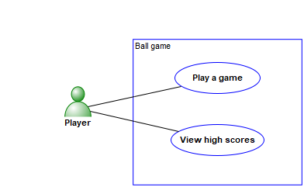

Graph dictionary
Object | Type of Object | Documentation
Player | Actor [UML] | Player who plays the ball game or views the high scores.
Ball game | System [UML]
Play a game | Use case [UML] | The user can play a game which a traditional ball game: player moves the paddle and tries to remove the bricks from the field by hitting them with the ball. The player has three balls per game.
View high scores | Use case [UML] | Scores of the best games and stored automatically and the user can view top 10 list. The list includes scores and player names.

Player: Actor [UML]
Properties:
Actor name | Player
Documentation | Player who plays the ball game or views the high scores.

Player relationships:
In role | In relationship | With objects(s) | In role
: Association role | : Association [UML] | Play a game | : Association role
: Association role | : Association [UML] | View high scores | : Association role

Player links:
Link type | Graph's name
Decomposition | none
Explosions | none

Ball game: System [UML]
Properties:
System name | Ball game
Documentation

Ball game relationships:
none

Ball game links:
Link type | Graph's name
Decomposition | none
Explosions | none

Play a game: Use case [UML]
Properties:
Use case name | Play a game
Attributes
Operations
Documentation file
Extension points
Documentation | The user can play a game which a traditional ball game: player moves the paddle and tries to remove the bricks from the field by hitting them with the ball. The player has three balls per game.

Play a game relationships:
In role | In relationship | With objects(s) | In role
: Association role | : Association [UML] | Player | : Association role

Play a game links:
Link type | Graph's name
Decomposition | none
Explosions | Ball Game behaviour - Design

View high scores: Use case [UML]
Properties:
Use case name | View high scores
Attributes
Operations
Documentation file
Extension points
Documentation | Scores of the best games and stored automatically and the user can view top 10 list. The list includes scores and player names.

View high scores relationships:
In role | In relationship | With objects(s) | In role
: Association role | : Association [UML] | Player | : Association role

View high scores links:
Link type | Graph's name
Decomposition | none
Explosions | none

Sub-objects:

Joe Smith: Person
Properties:
Name | Joe Smith
E-mail | mailto:info@metacase.com
Contact address | www.metacase.com

