Ball Game behaviour - Design
Documentation Report

Filename: | Ball Game behaviour - Design.docx
Status: | draft
Date: | 28.11.2025
Author: | David Hill

Ball Game behaviour - Design: Sequence Diagram
Graph properties:
Model name | Ball Game behaviour - Design
Status | draft
Authors | David Hill
Documentation | This model describes interactions among the Ball game objects during the game.

Diagram picture: Ball Game behaviour - Design
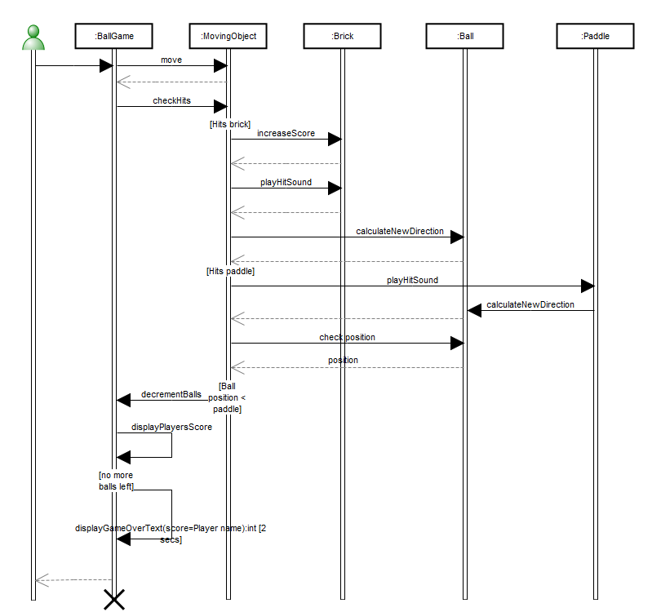

Graph dictionary
Object | Type of Object | Documentation
:Ball | Lifeline object
:BallGame | Lifeline object
:Brick | Lifeline object
:MovingObject | Lifeline object
:Paddle | Lifeline object
Outside actor | Outside actor

:Ball: Lifeline object
Properties:
Object name
Class | Ball
Stop? | F
Documentation

:Ball relationships:
In role | In relationship | With objects(s) | In role
: Message to | calculateNewDirection: Call | :MovingObject | : Message from
: Message to | calculateNewDirection: Call | :Paddle | : Message from
: Message to | check position: Call | :MovingObject | : Message from
: Return from | : Return | :MovingObject | : Return to
: Return from | position: Return | :MovingObject | : Return to
: Return from | : Return | :MovingObject | : Return to

:Ball links:
Link type | Graph's name
Decomposition | none
Explosions | none

:BallGame: Lifeline object
Properties:
Object name
Class | BallGame
Stop? | T
Documentation

:BallGame relationships:
In role | In relationship | With objects(s) | In role
: Message from | displayPlayersScore: Call | :BallGame | : Message to
: Message from | displayGameOverText: Call | :BallGame | : Message to
: Message from | move: Call | :MovingObject | : Message to
: Message from | checkHits: Call | :MovingObject | : Message to
: Message to | displayPlayersScore: Call | :BallGame | : Message from
: Message to | displayGameOverText: Call | :BallGame | : Message from
: Message to | decrementBalls: Call | :MovingObject | : Message from
: Message to | : Call | Outside actor | : Message from
: Return from | : Return | Outside actor | : Return to
: Return to | : Return | :MovingObject | : Return from

:BallGame links:
Link type | Graph's name
Decomposition | none
Explosions | none

:Brick: Lifeline object
Properties:
Object name
Class | Brick
Stop? | F
Documentation

:Brick relationships:
In role | In relationship | With objects(s) | In role
: Message to | increaseScore: Call | :MovingObject | : Message from
: Message to | playHitSound: Call | :MovingObject | : Message from
: Return from | : Return | :MovingObject | : Return to
: Return from | : Return | :MovingObject | : Return to

:Brick links:
Link type | Graph's name
Decomposition | none
Explosions | none

:MovingObject: Lifeline object
Properties:
Object name
Class | MovingObject
Stop? | F
Documentation

:MovingObject relationships:
In role | In relationship | With objects(s) | In role
: Message from | check position: Call | :Ball | : Message to
: Message from | decrementBalls: Call | :BallGame | : Message to
: Message from | playHitSound: Call | :Brick | : Message to
: Message from | playHitSound: Call | :Paddle | : Message to
: Message from | increaseScore: Call | :Brick | : Message to
: Message from | calculateNewDirection: Call | :Ball | : Message to
: Message to | move: Call | :BallGame | : Message from
: Message to | checkHits: Call | :BallGame | : Message from
: Return from | : Return | :BallGame | : Return to
: Return to | : Return | :Brick | : Return from
: Return to | : Return | :Ball | : Return from
: Return to | position: Return | :Ball | : Return from
: Return to | : Return | :Ball | : Return from
: Return to | : Return | :Brick | : Return from

:MovingObject links:
Link type | Graph's name
Decomposition | none
Explosions | none

:Paddle: Lifeline object
Properties:
Object name
Class | Paddle
Stop? | F
Documentation

:Paddle relationships:
In role | In relationship | With objects(s) | In role
: Message from | calculateNewDirection: Call | :Ball | : Message to
: Message to | playHitSound: Call | :MovingObject | : Message from

:Paddle links:
Link type | Graph's name
Decomposition | none
Explosions | none

Outside actor: Outside actor
Properties:
none

Outside actor relationships:
In role | In relationship | With objects(s) | In role
: Message from | : Call | :BallGame | : Message to
: Return to | : Return | :BallGame | : Return from

Outside actor links:
Link type | Graph's name
Decomposition | none
Explosions | none

Sub-objects:

David Hill: Person
Properties:
Name | David Hill
E-mail | mailto:info@metacase.com
Contact address | Park Court  Upper Essex Street  City 5  B8 6QB

Ball: Class [UML]
Properties:
Class name | Ball
Attributes
Operations | +display()void , +calculateNewDirection(hitObject:MovingObject)void , +check position()void
Package | Game
Abstract? | F
Active? | F
Stereotype
Overridability
Role
Parameters
Constraints
Invariant
Derivation rules
Responsibility
Documentation | Ball is the basic element of the game. Player tries to remove bricks by hitting them with the ball.
Simple symbol? | F

+display()void: Operation [UML]
Properties:
Operation name | display
Parameters
Return type
Overridability
Stereotype
Visibility | public
Operation type | instance
Query? | F
Preconditions
Postconditions
Body
Documentation | Overriden from superclass to display a round ball rather than a square

+calculateNewDirection(hitObject:MovingObject)void: Operation [UML]
Properties:
Operation name | calculateNewDirection
Parameters | in hitObject:MovingObject
Return type
Overridability
Stereotype
Visibility | public
Operation type | instance
Query? | F
Preconditions
Postconditions
Body
Documentation

in hitObject:MovingObject: Parameter
Properties:
Parameter | hitObject
Data type | MovingObject
Direction | in
Default value
Effect
Exception? | F
Stream? | F

+check position()void: Operation [UML]
Properties:
Operation name | check position
Parameters
Return type
Overridability
Stereotype
Visibility | public
Operation type | instance
Query? | F
Preconditions
Postconditions
Body
Documentation | Returns the location of the ball.

Game: Package
Properties:
Package name | Game
Stereotype | modelLibrary
Documentation | Ball game packace include all the components of the ball game application. Because the application is small not other packages are used for categorization.

BallGame: Class [UML]
Properties:
Class name | BallGame
Attributes
Operations
Package
Abstract? | T
Active? | F
Stereotype
Overridability
Role
Parameters
Constraints
Invariant
Derivation rules
Responsibility
Documentation
Simple symbol? | T

Brick: Class [UML]
Properties:
Class name | Brick
Attributes | +value:int =1
Operations | +playHitSound()void , +increaseScore()void
Package | Game
Abstract? | F
Active? | F
Stereotype
Overridability
Role
Parameters
Constraints
Invariant
Derivation rules
Responsibility
Documentation | Single element of the wall. These will disappear, when the ball hits them.
Simple symbol? | F

+value:int =1: Attribute [UML]
Properties:
Name | value
Data type | int
Default value | 1
Multiplicity
Ordered? | F
Unique? | T
Sequence? | F
Stereotype
Visibility | public
Scope | instance
Access
Derived? | F
Constraints
Documentation | Value of the brick. When ball hits the brick, value will be added to player's currentScore.

+playHitSound()void: Operation [UML]
Properties:
Operation name | playHitSound
Parameters
Return type
Overridability
Stereotype
Visibility | public
Operation type | instance
Query? | F
Preconditions
Postconditions
Body
Documentation | When the ball hits a brick or a paddle, it makes a sound.

+increaseScore()void: Operation [UML]
Properties:
Operation name | increaseScore
Parameters
Return type
Overridability
Stereotype
Visibility | public
Operation type | instance
Query? | F
Preconditions
Postconditions
Body
Documentation | When then ball hits a brick it will disappear and the value of the brick will be added to player's currentScores.

MovingObject: Class [UML]
Properties:
Class name | MovingObject
Attributes | +position:Point =100.0@100.0 , -velocity:Point =0.0@2.0 , +extent:Point , -colour:ColorValue
Operations | +display()void , +move(position:Point, direction:int)void , +checkHits()void
Package | Game
Abstract? | T
Active? | F
Stereotype
Overridability
Role | model
Parameters
Constraints
Invariant
Derivation rules
Responsibility
Documentation | MovingObject is an abstract class for all moving components of the ball game.
Simple symbol? | F

+position:Point =100.0@100.0: Attribute [UML]
Properties:
Name | position
Data type | Point
Default value | 100.0@100.0
Multiplicity
Ordered? | F
Unique? | T
Sequence? | F
Stereotype
Visibility | public
Scope | class
Access
Derived? | F
Constraints
Documentation | Position stores the current location of the top left corner of the moving object in the game.

-velocity:Point =0.0@2.0: Attribute [UML]
Properties:
Name | velocity
Data type | Point
Default value | 0.0@2.0
Multiplicity
Ordered? | F
Unique? | T
Sequence? | F
Stereotype
Visibility | private
Scope | instance
Access
Derived? | F
Constraints
Documentation | Stores the direction and speed of the movement. Positive x values are to the right, positive y values up

+extent:Point: Attribute [UML]
Properties:
Name | extent
Data type | Point
Default value
Multiplicity
Ordered? | F
Unique? | T
Sequence? | F
Stereotype
Visibility | public
Scope | instance
Access
Derived? | F
Constraints
Documentation | Moving objects have width and height

-colour:ColorValue: Attribute [UML]
Properties:
Name | colour
Data type | ColorValue
Default value
Multiplicity
Ordered? | F
Unique? | T
Sequence? | F
Stereotype
Visibility | private
Scope | instance
Access
Derived? | F
Constraints
Documentation | Colour of the moving object.

+display()void: Operation [UML]
Properties:
Operation name | display
Parameters
Return type
Overridability
Stereotype
Visibility | public
Operation type | instance
Query? | F
Preconditions
Postconditions
Body
Documentation | Displays the object at its current position. The default is to fill its extent with its colour; subclasses can override for more interesting shapes and effects.

+move(position:Point, direction:int)void: Operation [UML]
Properties:
Operation name | move
Parameters | in position:Point , in direction:int
Return type
Overridability
Stereotype | action
Visibility | public
Operation type | instance
Query? | F
Preconditions | Is not outside the game field, ie. player has not missed the ball.
Postconditions
Body
Documentation | Move changes the location and direction of the moving object in the game field according to the given position and direction.

in position:Point: Parameter
Properties:
Parameter | position
Data type | Point
Direction | in
Default value
Effect
Exception? | F
Stream? | F

in direction:int: Parameter
Properties:
Parameter | direction
Data type | int
Direction | in
Default value
Effect
Exception? | F
Stream? | F

+checkHits()void: Operation [UML]
Properties:
Operation name | checkHits
Parameters
Return type
Overridability
Stereotype
Visibility | public
Operation type | instance
Query? | F
Preconditions
Postconditions
Body
Documentation | Check whether moving object has hit some other object.

Paddle: Class [UML]
Properties:
Class name | Paddle
Attributes | +maxSpeed
Operations | +playHitSound()void
Package | Game
Abstract? | F
Active? | F
Stereotype
Overridability
Role
Parameters
Constraints
Invariant
Derivation rules
Responsibility
Documentation | Player tries to keep the ball in play by hitting  it with the paddle.
Simple symbol? | F

+maxSpeed: Attribute [UML]
Properties:
Name | maxSpeed
Data type
Default value
Multiplicity
Ordered? | F
Unique? | T
Sequence? | F
Stereotype
Visibility | public
Scope | instance
Access
Derived? | F
Constraints
Documentation | Maximum speed of the paddle can change during the game

